**[BUSINESS](https://www.readingeagle.com/business/)**

**Residents group wins legal fight over plans for warehouse in northern Berks**

A ruling by state Commonwealth Court requires a new vote on plans for a distribution center in Maxatawny Township.

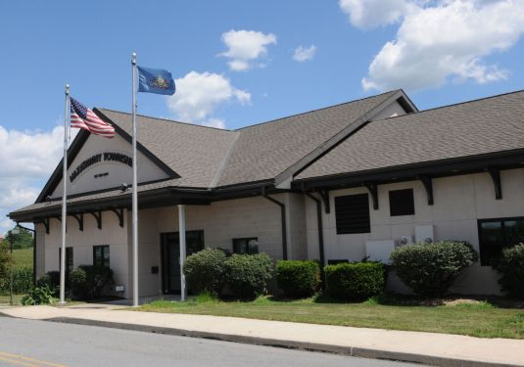

Residents group wins legal fight over plans for warehouse in northern Berks

By [**KEITH DMOCHOWSKI**](https://www.readingeagle.com/author/keith-dmochowski/) | [kdmochowski@readingeagle.com](mailto:kdmochowski@readingeagle.com) |

Reading Eagle

PUBLISHED: April 11, 2023 at 10:00 a.m. |

UPDATED: April 12, 2023 at 3:00 p.m.

A residents group claimed a major legal victory against plans for a 1.6 million-square-foot warehouse center north of Route 222 in Maxatawny Township last week when the state Commonwealth Court ruled against the plans’ approval.

A judge ruled the supervisors’ vote approving the plans was invalid and that a zoning variance and special exception would be needed for the project to proceed.

The plans by developer Duke Realty of Indiana call for a distribution center between Route 222, Long Lane Road, and Hilltop Road, with Hottenstein Road passing through the site.

They were approved by the supervisors in June 2021 over the objections of residents worried about the project’s effect on traffic — in particular the 5,000 daily vehicle trips that the facility would bring to local roads, including 2,000 involving tractor-trailers.

Conditions of the preliminary approval included the developer paying the township a $1.3 million traffic impact fee and $600,000 for road improvements as well as the installation of a roundabout nearby.

At the time of the plans’ approval, residents voiced concerns over the project’s impact on the local Mennonite community, whose members travel the same roads via horse-and-buggy and bicycle.

**Conflict of interest concerns**

Residents also alleged conflicts of interest stemming from two supervisors’ connection to the project.

According to court documents, Supervisor Heath Wessner and then-Supervisor Allen Leiby’s son-in-law and sister owned land subject to purchase agreements with Duke.

In July 2021, a group of 15 residents appealed the Duke plan approval to Berks County Court. That appeal was denied, and the residents brought their case before Commonwealth Court in the following months.

Supervisors argued that the vote to approve the plans was allowed by the state Ethics Commission, which told the township before the vote that though two supervisors have a clear conflict of interest, state law allows them to vote because the three-supervisor board wouldn’t have enough members to hold a vote without them.

Residents also claimed that the plans needed zoning relief — including land use variances and a special exception — but no relief was ever granted.

Maxatawny officials said they interpreted the rules requiring zoning relief differently due to conflicting passages in the zoning ordinance.

**The ruling**

In the ruling April 6, Judge Christine Fizzano Cannon wrote that state law not only allowed but required both conflicted supervisors to vote on the warehouse plans’ approval, meaning the 2-0 vote — where Leiby and Supervisor Judy Daub voted, but Wessner recused himself due to his conflict of interest — was invalid.

The ruling also upheld residents’ interpretation of the zoning rules, finding that developers need a variance from rules requiring that no warehouse be located within 500 feet of a residential property.

In addition, the court found that according to Maxatawny’s zoning ordinance, a special exception would be needed for the warehouse facility.

The Commonwealth Court ruled to vacate the Berks court’s decision upholding the plans’ approval.

According to the ruling, supervisors will have to cast a new vote on the plans — but only after Duke secures the required zoning relief.

The ruling clarifies that since only one current supervisor —Wessner — has a conflict of interest, the vote may fall to the township’s two supervisors without a conflict of interest: Daub and John Deplanque.

Deplanque defeated Leiby in the 2021 election, campaigning against the project due to its potential impact on traffic and the environment.

In the event of a tie vote, plan approval will be denied according to legal precedent, the ruling said.

Township officials and Duke have 30 days to appeal the ruling.

The warehouse plans were also subject to litigation in 2021, when descendants of those buried in the Kemp Burial Ground on the warehouse site sued Duke for the plans’ proposal to relocate the graves.

That matter was settled with an order from the Berks County Orphans’ Court that the graves stay in place.